18th Annual Harvest Pumpkin Festival
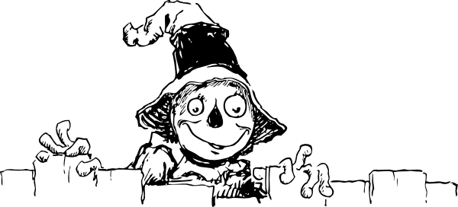
Scarecrows
on the Street

Enter your business in the ‘Scarecrows on the Street’ Decorating Challenge!

All businesses and organizations are invited to participate! Display, window or property decorations should fit the ‘harvest’ theme and must include at least one handmade scarecrow – no size limitation.

NEW!! This year, the focus will to benefit our local food bank and judging will be ‘People’s Choice’. Residents and visitors will pick up a map at the Visitor Centre beginning October 5th, visit participating locations, then vote by depositing a non-perishable food item in the tote located beside their favourite scarecrow. All ‘votes’ must be in the donation totes by October 19th at 4pm. Winners will be notified October 22nd once the Armstrong Food Bank has tabulated the results.

After October 19th, feel free to add some ‘Hallowe’en’ props to your display in preparation for the annual ‘Downtown Trick or Treat Spooktacular’ October 31st.

Fill in the form below and return to the AS Chamber of Commerce by Friday Sept. 28 to be included on the ‘Scarecrows on the Street’ map and receive an official ‘donation tote’. The map will be available online beginning October 5 and distributed at HPF Family Day Oct. 6; participating businesses will also have maps – just let us know how many you would like.

Winner of the People’s Choice will win a complimentary spot in the 105.7 Sun FM Fun Friday in November promoting the upcoming holiday shopping season. 2nd & 3rd place will receive treats to enjoy with your staff and/or volunteers.
- - - - - - - - - - - - - - - - - - - - - - - - - - - - - - - - - - - - - - - - - - - - - - - - - - -

Name of Business/Organization: _________________________________________________

Contact Person: ______________________________________________________________
