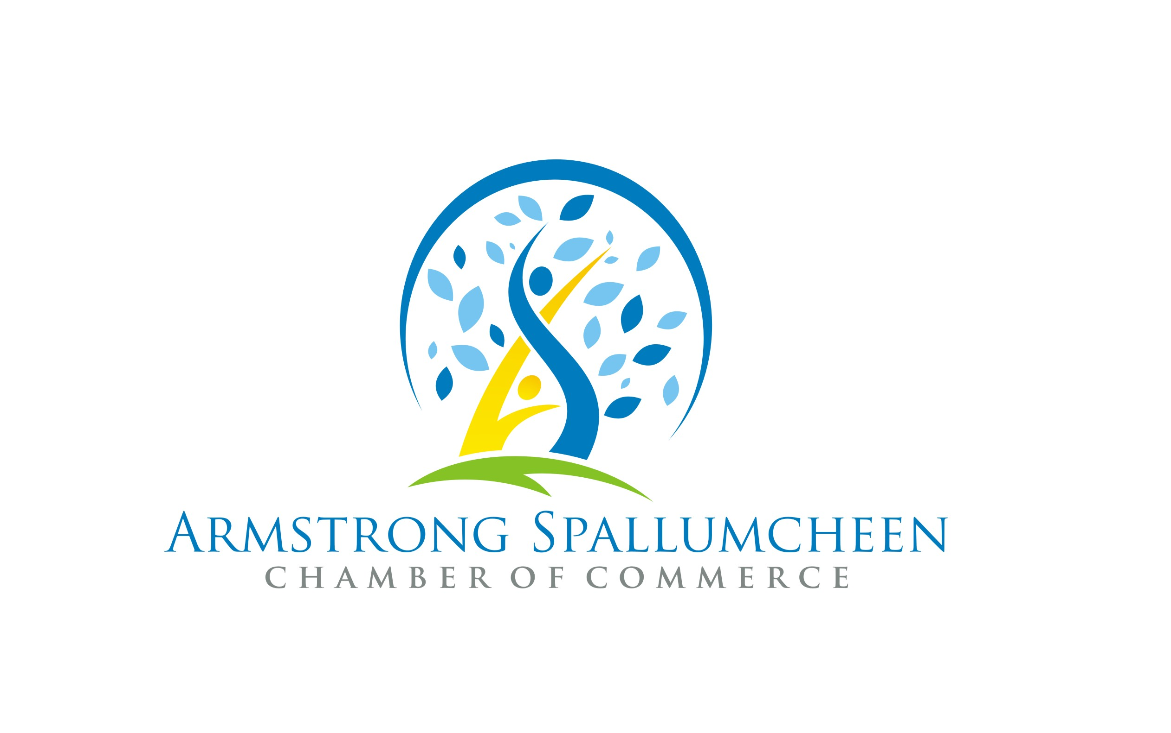

VENDOR REGISTRATION
16th Annual Harvest Pumpkin Festival
‘Family Day’
October 8 2016 in Horticultural Building on IPE Fairgrounds 9am – 2pm

PLEASE PRINT:

Vendor’s Business Name:____________________________________________________

Vendor Name:____________________________________________________________

Mailing Address:__________________________________________________________

Telephone: _____________________ E-Mail:__________________________________

Activity/Product(s) for sale:___________________________________________________ ____________________________________________________________________________________________________________________________________________
Special Requirements:_______________________________________________________
____________________________________________________________________________________________________________________________________________
- $25 per 8 x8 inside space – vendors must provide their own tables and chairs – all tables must be covered – harvest/fall decorations are encouraged. We can provide a table for $10.
- All vendor information sheets should be returned to the Chamber of Commerce by Oct. 1st
- Set up by 8:30 am - booths must remain in place until 2:o0pm.

- Some Electricity Available

- No BBQ or grill inside the building – contact us for information on outdoor space

- Dress warmly – the facility can be chilly depending on the weather!

