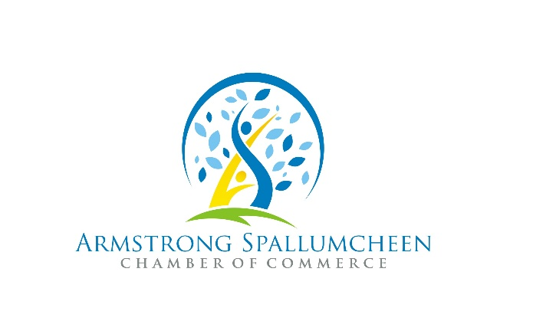

Press Release - PSA

For Immediate Release
June 15, 2022

June 21 is National Indigenous Peoples Day. This is a day for all Canadians to recognize and celebrate the unique heritage, diverse cultures and outstanding contributions of First Nations, Inuit and Métis peoples.

In our community, with the support of the Splatsin First Nations, we will be hosting a Twilight Market celebrating & recognizing National Indigenous Peoples Day with food, live music, Indigenous/Non-Indigenous artists and artisans - and more!

This is event is to bring awareness of the Secwepemc region including Splatsin and showcasing the many contributions they bring to us as we move towards true reconciliation which includes listening and learning.

We invite everyone to celebrate and engage with the community at this FREE event which takes place on the traditional and unceded territory of the Secwépemc (Secwépemcúl’ecw) People.

Tuesday June 21 2022 | 5-8pm | Pleasant Valley Blvd (North & South) Armstrong BC

For the most current schedule of activities please go to
https://www.aschamber.com/schedule-of-activities.html
This free family event is made possible through contributions and participation of the Splatsin First Nations, City of Armstrong, Township of Spallumcheen and the Department of Canadian Heritage.
For a complete list of Celebrate Canada events and a Canada Day schedule, go to https://www.aschamber.com/countdown-to-canada-day.html or on Facebook @ASCanadaDay2022
For more information on this press release contact:

Patti Noonan, Executive Director
Armstrong Spallumcheen Chamber of Commerce & Visitor Centre
manager@aschamber.com

