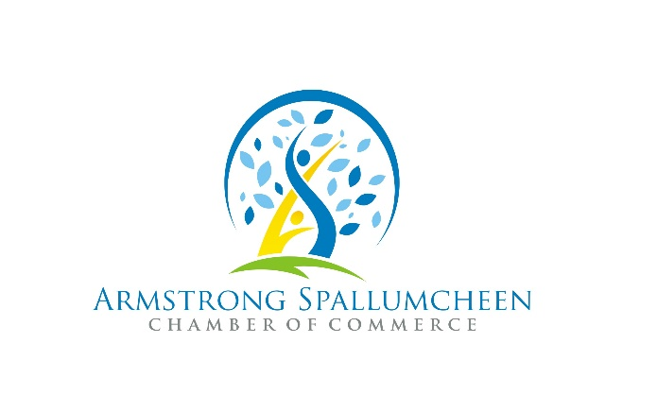

Press Release - PSA

For Immediate Release
June 16, 2022

On June 27, National Multiculturalism Day honours the many cultural communities that help build a strong and vibrant Canadian society.

Take this opportunity to celebrate the diversity that enriches us collectively and reaffirm your commitment to equity, inclusion, and mutual respect.

In our community, we will be hosting a FREE celebration with food, live music, art and cultural presentations.

Multiculturalism is one of Canada’s great strengths. We encourage you to share your experience, and your story with others and listen to theirs at this event.

Cultural presentations by Kelowna Bhangra School, Blakely Okanagan Irish Dance, Vernon Chidorikai Japanese Dancers & a student led GSA Diversity Exhibit.

Cultural food and beverage provided by Handmade by Georgia, Finca Las Magaritas Coffee, Taste of Egypt, Meenu Indian Cusine and Greek Chariot.

Monday June 27 2022 | 5-8pm | Memorial Park Armstrong BC
This free family event is made possible through contributions and participation of the City of Armstrong, Township of Spallumcheen and the Department of Canadian Heritage.
For a complete list of Celebrate Canada events and a Canada Day schedule, go to https://www.aschamber.com/countdown-to-canada-day.html or on Facebook @ASCanadaDay2022
For more information on this press release contact:

Patti Noonan, Executive Director
Armstrong Spallumcheen Chamber of Commerce & Visitor Centre
manager@aschamber.com

