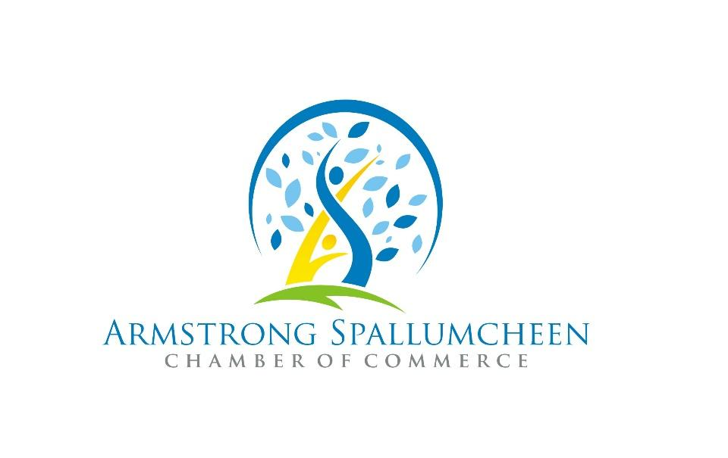
For immediate release
May 23 2023

Multicultural Day in Armstrong Spallumcheen
On June 27, National Multiculturalism Day honours the many cultural communities that help build a strong and vibrant Canadian society.
Take this opportunity to celebrate the diversity that enriches us collectively and reaffirm your commitment to equity, inclusion, and mutual respect.
In our community, we will be hosting a FREE celebration with food, live music, art and cultural presentations.
Multiculturalism is one of Canada’s great strengths. We encourage you to share your experience, and your story with others and listen to theirs at this event.
Cultural presentations by Jabulani Drummers, Blakely Okanagan Irish Dance, Vernon Chidorikai Japanese Dancers, Kesavah Dancers and TKH Bollywood Dancers. Cultural food and beverage provided by Finca Las Magaritas Coffee, and HT Asian Market.
Tuesday June 27 2022 | 5-8pm | Memorial Park Armstrong BC
This free family event is made possible through contributions and participation of the City of Armstrong, Township of Spallumcheen, Armstrong Spallumcheen Chamber of Commerce and the Department of Canadian Heritage.
For a complete list of Celebrate Canada events and a Canada Day schedule, go to https://www.aschamber.com/countdown-to-canada-day.html or on Facebook @ASCanadaDay2022

For more information on this press release contact:
Patti Noonan, Executive Director
Armstrong Spallumcheen Chamber of Commerce & Visitor Centre manager@aschamber.com

