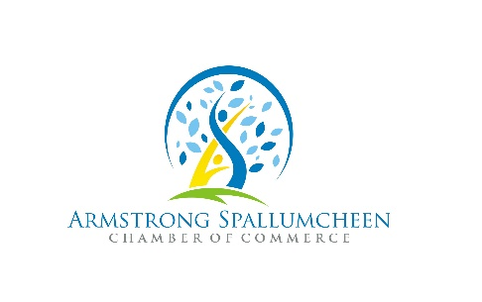

We Provide…
Sponsor/Manager AS Visitor Centre
Event ticket sales
Tent loans
Grant application assistance
Export Certification
Meeting Space – 1x/month use of Chamber office space FREE (schedule permitting)

We Participate in…
the Armstrong Age-Friendly Committee
the Spallumcheen Ag Committee
the Armstrong Sister City Committee
planting Day with the city of Armstrong
We Organize…
Holiday ‘Shop Local’ events
Community Christmas Tree Decorating Cheese…It’s a Natural!

Ways YOUR Chamber of Commerce supports your business and community!

Harvest Pumpkin Festival
Countdown to Canada Day June 21 – July 1
Canada Day Celebrations in Memorial Park
Community Excellence Awards
Business after Business Networking – monthly event
Familiarization (Fam) Tours
North Okanagan Shuswap Barn Quilt Trail
All Candidate Forums
Music in the Park (June – August)
Children’s Bike Rodeo
Mini Tradeshows
Business Walk
Empty Storefront Tour

We Offer Advertising opportunities through…
Armstrong Spallumcheen visitor brochure
Area Map
Harvest Pumpkin Festival ads
Shop Local brochure in conjunction with Downtown Light Up
Manage AS Chamber & Armstrong Spallumcheen Fb pages
Online business directory
Website listing – FREE for members
Bits and Bytes bi-weekly e-letter – FREE for members…tell us about your upcoming events and specials!
Social media events listings – FREE for members
Sponsorship opportunities
Member racking (brochures, business cards) – FREE for members
Business Referrals – FREE
Flyer delivery – FREE to members – you print them, Kindale will deliver (through our office)

Plus…
BC Chamber program benefits

Please note these activities and promotions are subject to change.

